**______________________________________________**

**Western University**

**High-Altitude Balloon (HAB) Experiment**

**______________________________________________**

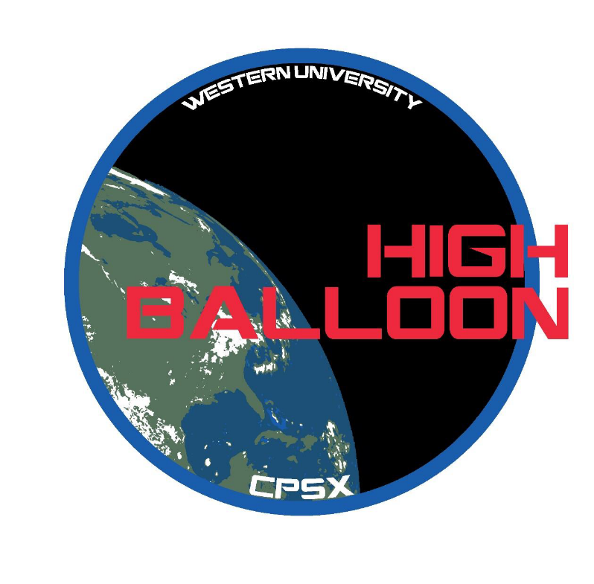

A student led project from the

*Centre for Planetary Sciences and Exploration (CPSX)*

Matt Svenssona, Alexis Pascualb, Gavin Tolomettia, Mohammed Chammac, Chimira Andresa, Kelsey Doerksenb, Nicole Devosb, Bryan Southwellb, Nikol Posnova, Bita Azadd, Rafael Nascimento de Aguiarb, Stephen Ameyb,c, and Jonathan Kissi-Ameyawb

a - Earth Science, b - Electrical and Computer Engineering, c - Physics and Astronomy,

d - Microbiology and Immunology

Western University

# CPSX High Altitude Balloon Initiative

The Centre for Planetary Science and Exploration’s (CPSX) 2019 High Altitude Balloon team is partnering with the Students for the Exploration and Development of Space (SEDS)-Canada and the Canadian Space Agency (CSA) to sample microbial aerosols via stratospheric balloon. The experiment payload will be supplied by the CPSX Team, the housing for the payload will be supplied through SEDS-Canada and the balloon and gondola will be supplied by the CSA as part their stratospheric balloon program, STRATOS [1]. SEDS-Canada has arranged to reserve two spaces on the CSA’s gondola (Fig 1), one of which has been granted to the CPSX team for this year’s launch. Our team is designing an experiment to study the varying character and population of microbial aerosols with altitude.

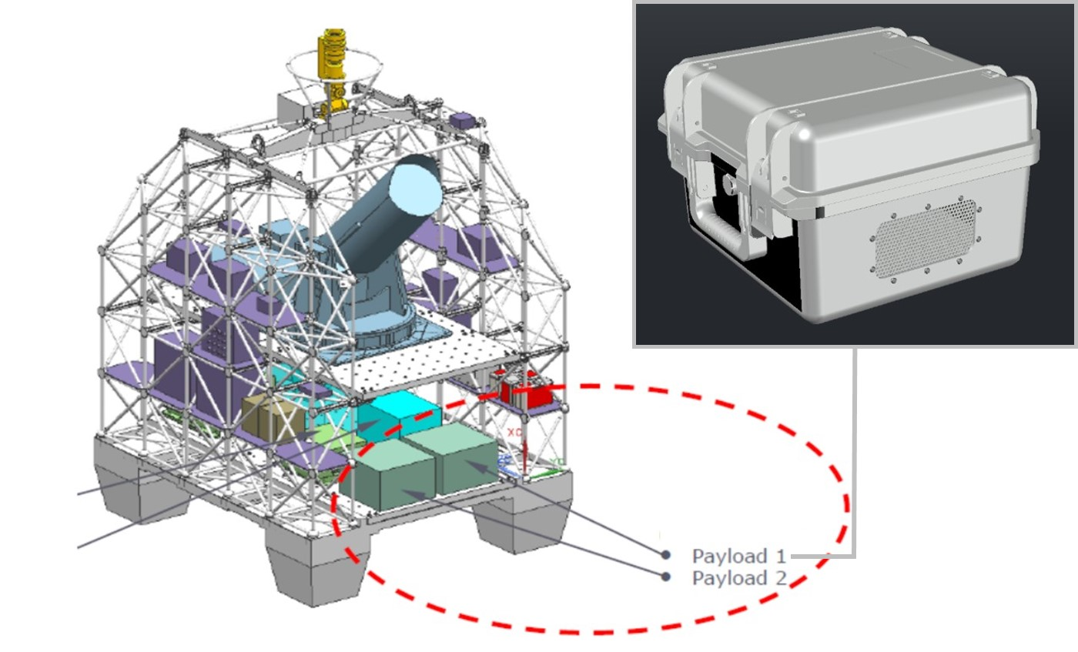

C

D

A

B

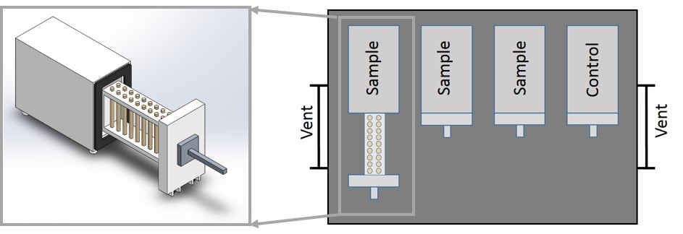

**Figure 1:** Project component summary. (A) CSA’s gondola highlighting SEDS-Canada payload locations. (B) CAD design of SEDS-Canada payload housing. (C) Concept for individual sampling unit. (D) UWO payload concept design.

# Objectives

The threshold goal of CPSX’s HAB project is to sample bioaerosols in the atmosphere at three or more points during the balloon’s initial ascent phase. Our extended goal to sample the atmosphere at 5 or more additional points during the ascent and extended level flight. We are applying a proven design concept from Bryan et al. (2014) who sampled microbial aerosols in the atmosphere using a minimal payload flown with a sounding balloon. The augmented mission objective is to simultaneously collect samples of atmospheric moisture using a separate system of a similar design, which can take the place of the additional sampling chambers required for the extended goal. Once the samples have been collected and returned, the microbial aerosols will be characterized and the origin of the air mass could be determined using *δ*18O and *δ*2H of hydrogen and oxygen isotope values of the sampled atmospheric moisture.

# Sampling System

The sampling system will be modified from Bryan et al. (2014) in order to better integrate with the STRATOS gondola and to accommodate a higher sampling resolution. Each chamber designed to sample microbial aerosols will hold 20 Rotorods ® each with a surface designed to sample via impaction. We suggest two potential mechanisms to open and close sampling chambers: (1) linear actuators and (2) driven screw systems. All in flight computer systems will be provided by the UWO team, however power will be supplied by the CSA’s gondola. The sampling system for atmospheric moisture is conceptual and there is currently no specific design to follow pending further input from subject matter experts. As such, moisture sampling remains an augmented mission object to be achieved if time permits it.

**Design Challenges Remaining:**

Mechatronics graduate student and faculty assistance:

* + Selection of appropriate materials
  + Sampling chamber design – overall difficulty with pressure equalization (luer lock with syringe filter – not fully understood how it works or where it sits in the chamber)
  + Measuring and designing for optimal air flow to the sampling chamber
  + Two Suggested Sampling Chamber Designs:
    - 1. **Drawer with screw:** need to determine size and power of servos and size of the screws
      2. **Drawer with linear actuator**: need to determine size and power of linear actuator

**General Project Timeline**

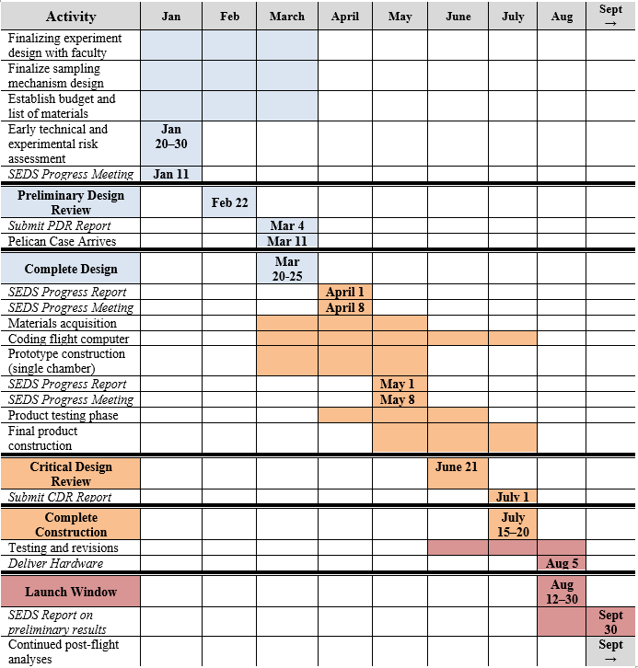

The general project timeline is broken down in town to four main phases: (1) logistics and design, (2) assembly, (3) testing / launch, and (4) data analysis.

**References:**

[1] http://www.asc-csa.gc.ca/eng/sciences/balloons/default.asp

[2] Bryan N.C., Stewart M., Granger D., Guzik T.G., Christner B.C. 2014. A method for sampling microbial aerosols using high altitude balloons*. Journal of Microbiological Methods*. **107**: 161–168.